Minikube start:

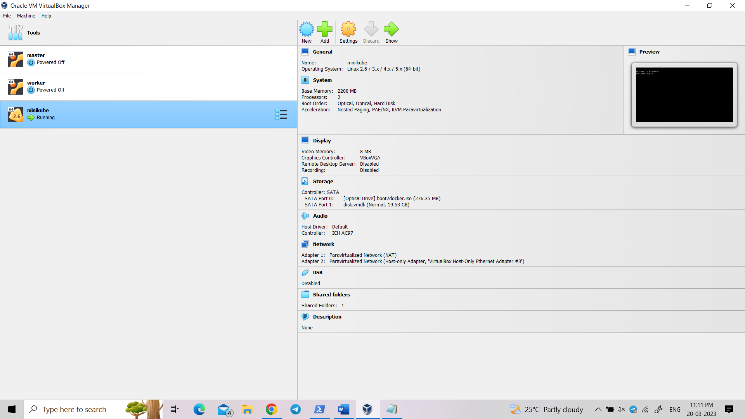

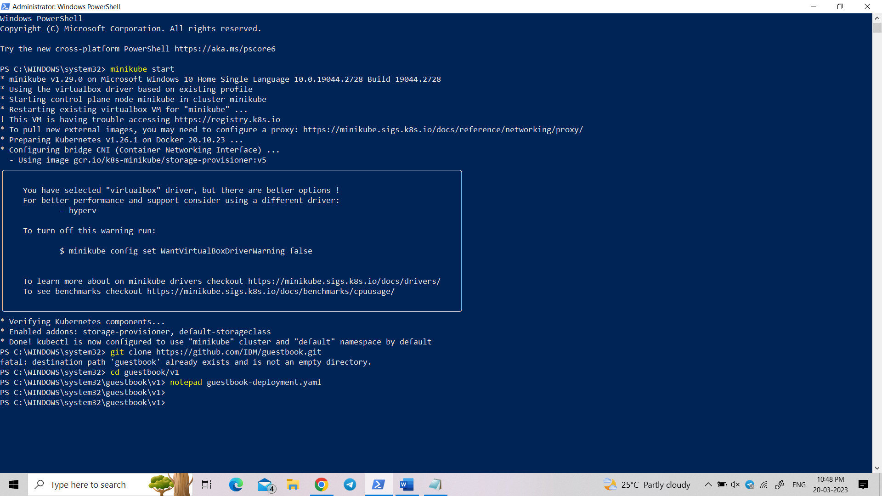

**guestbook-deployment.yaml:**

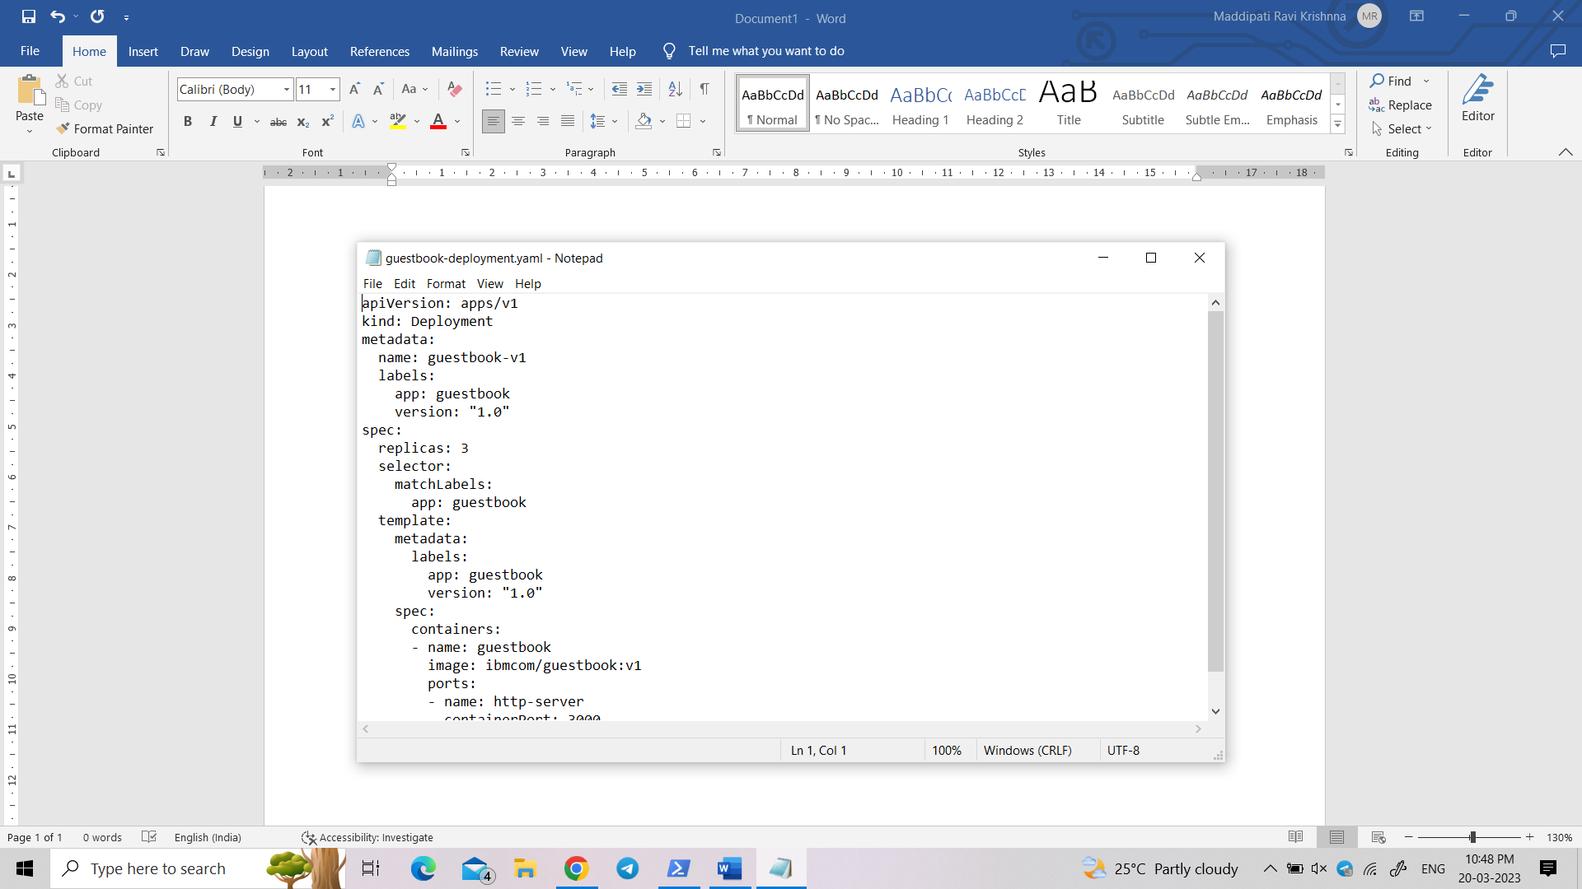

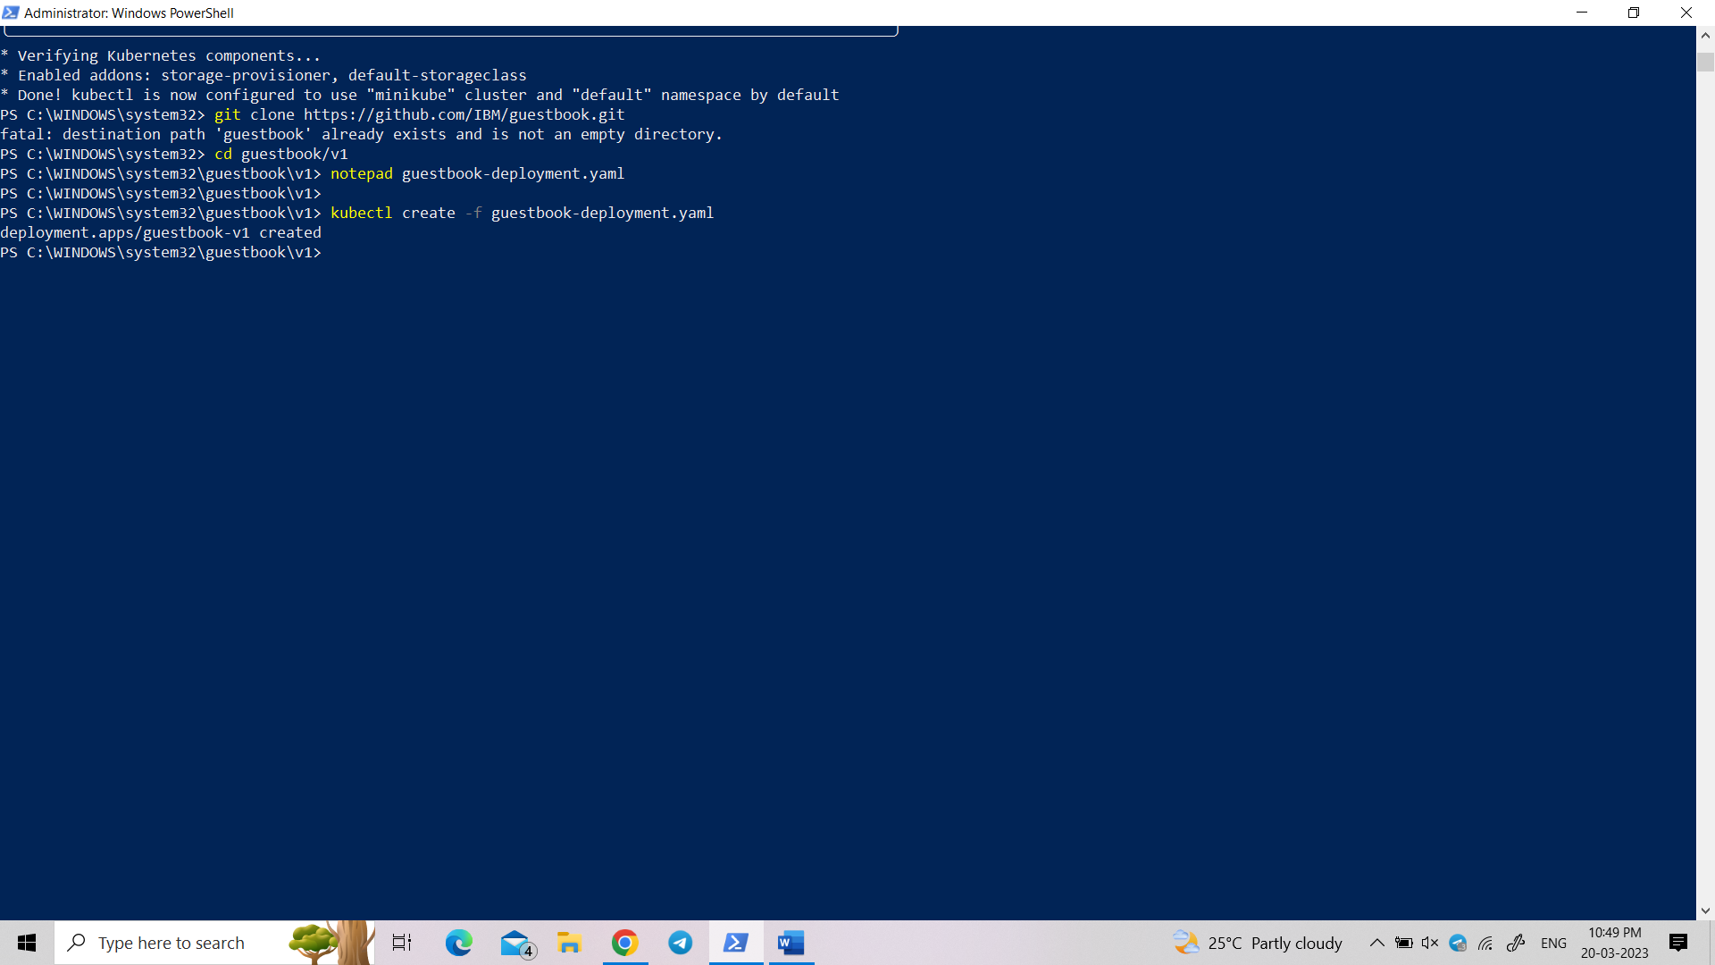

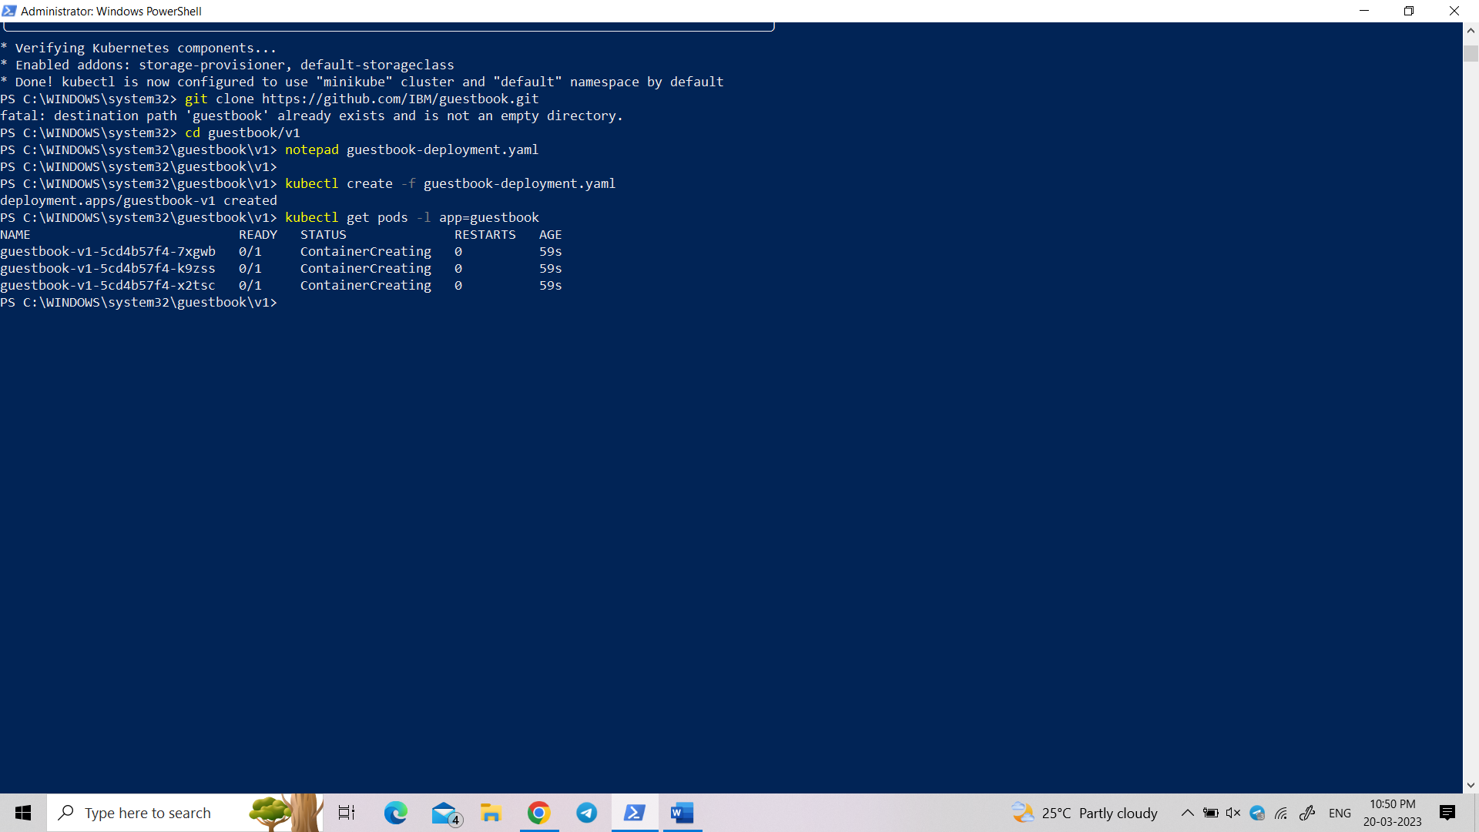

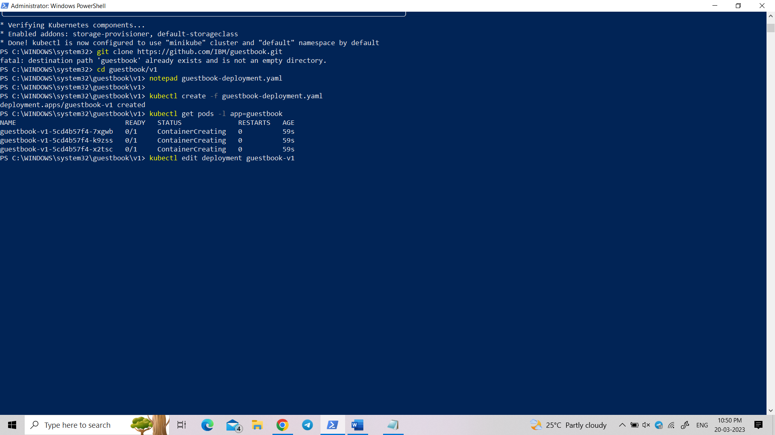

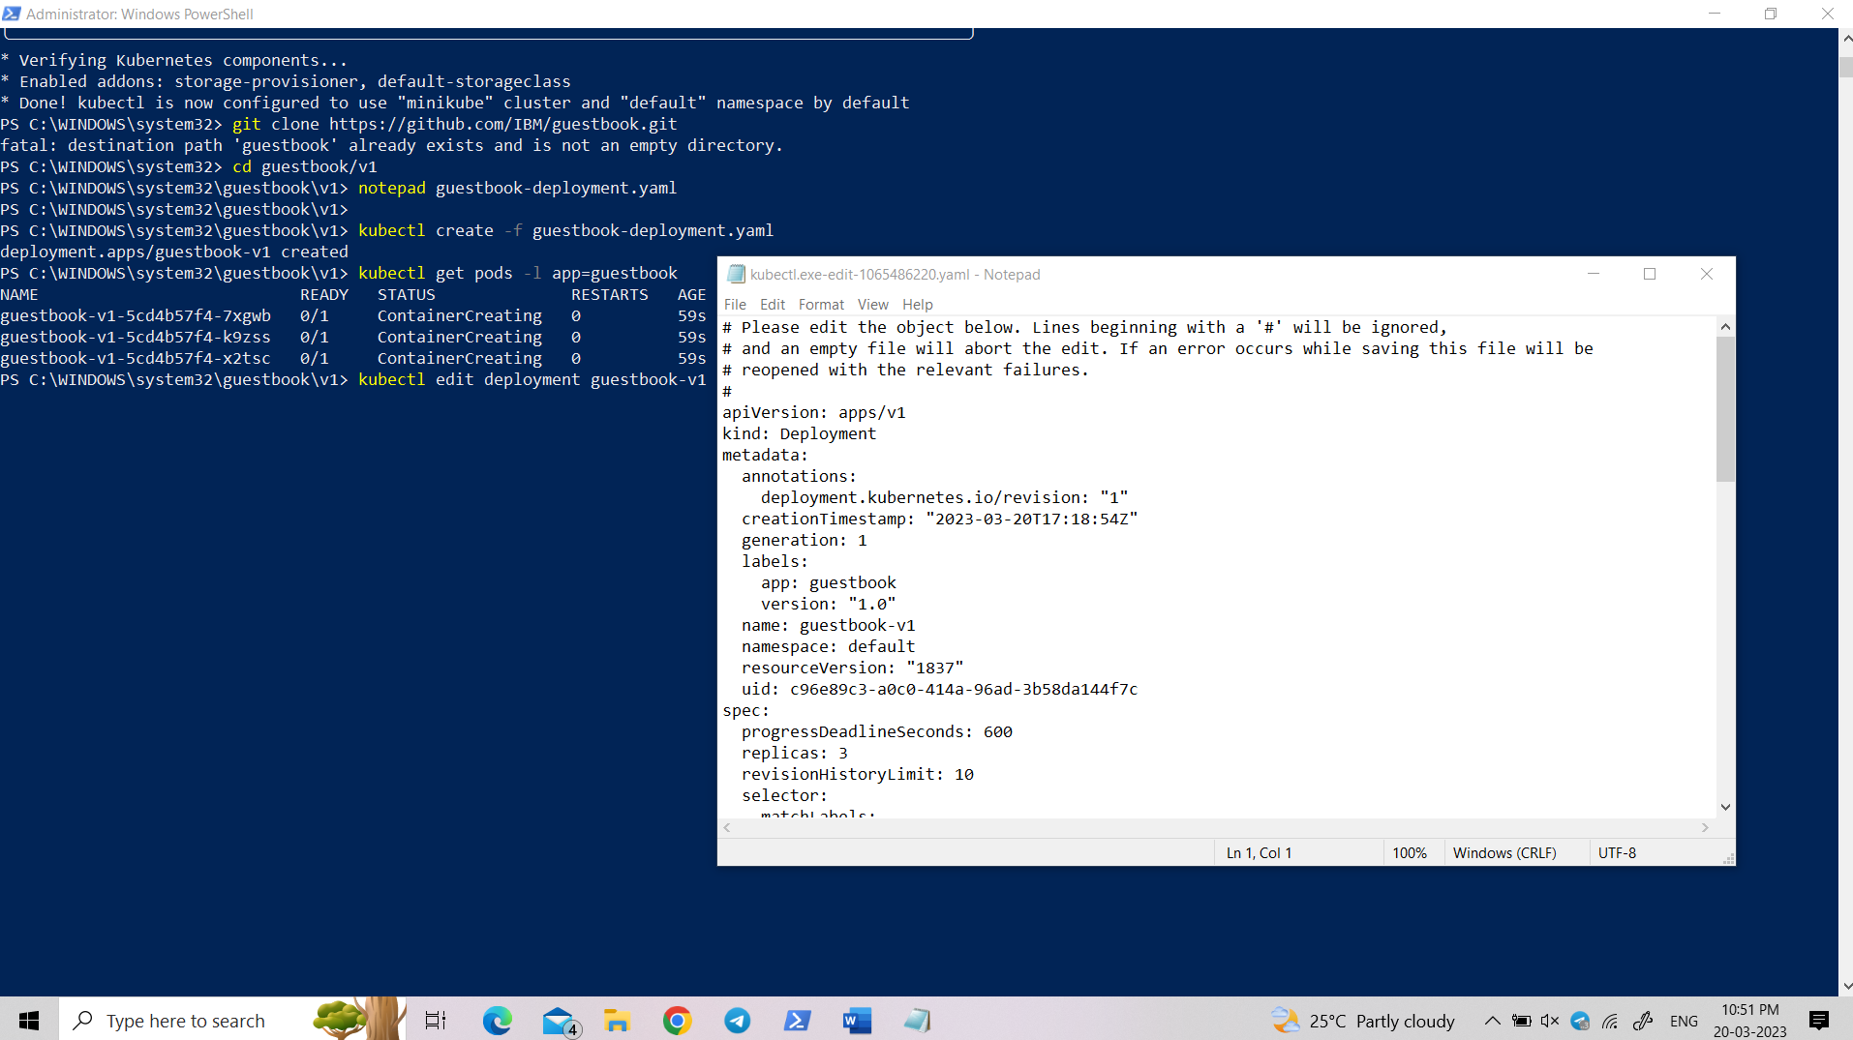

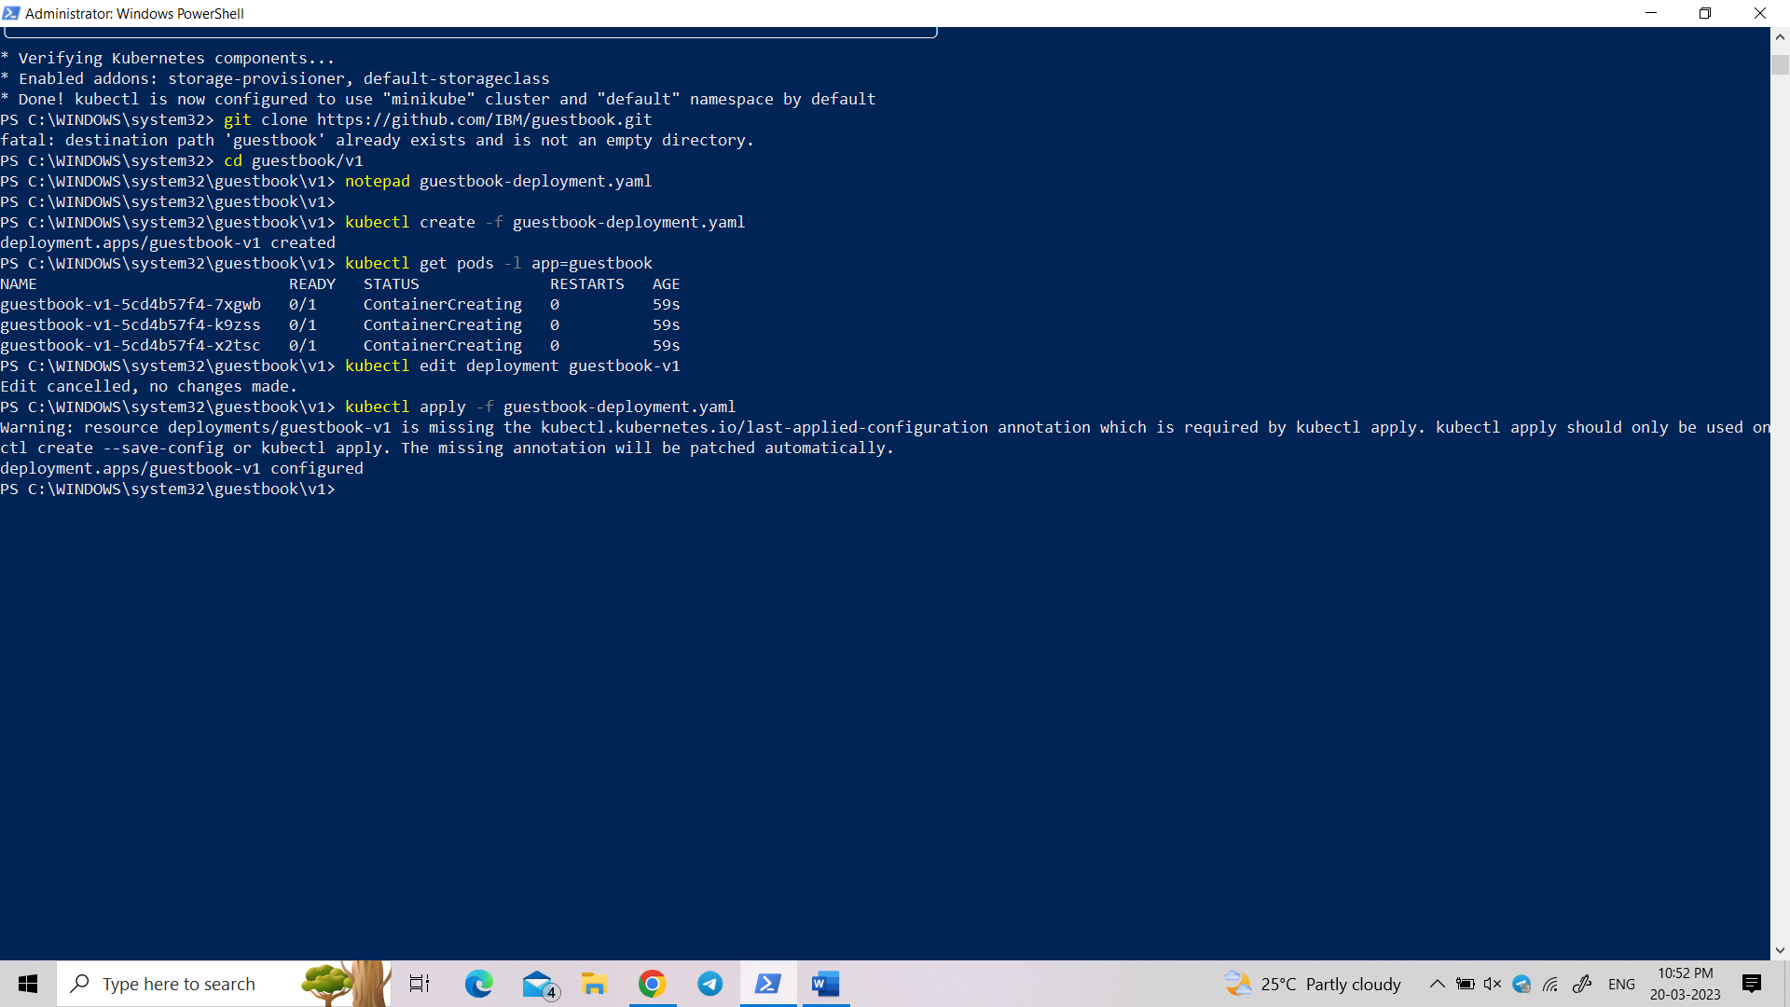

**guestbook-service.yaml:**

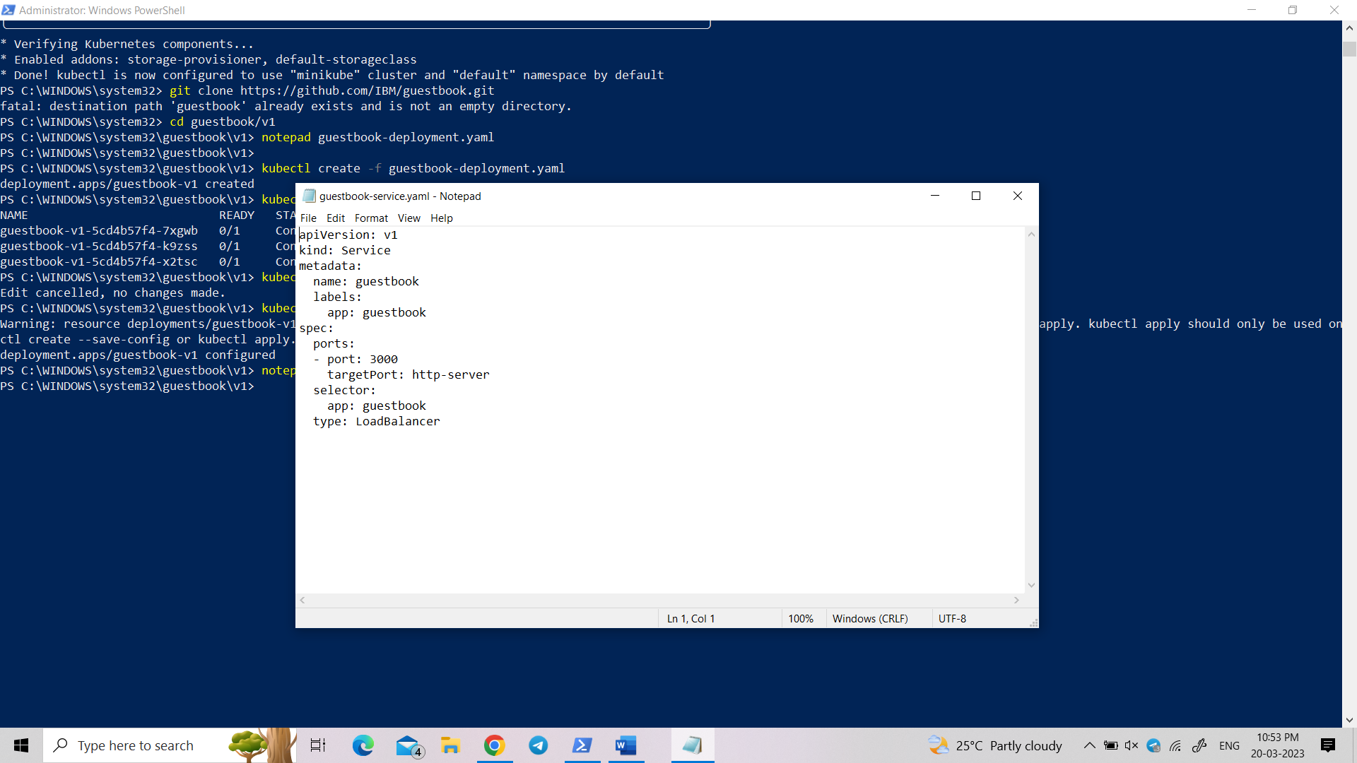

**Type these commands in PowerShell**

kubectl create -f guestbook-service.yaml

kubectl describe service guestbook

kubectl get nodes -o wide

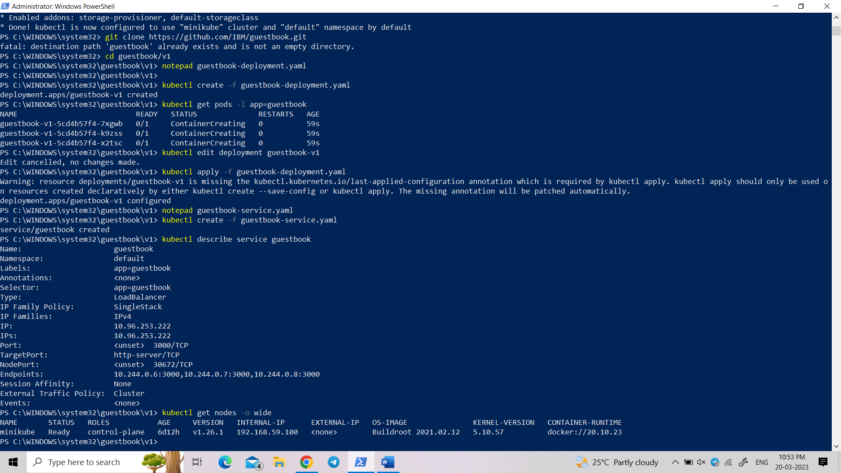

**Open redis-master-deployment.yaml:**

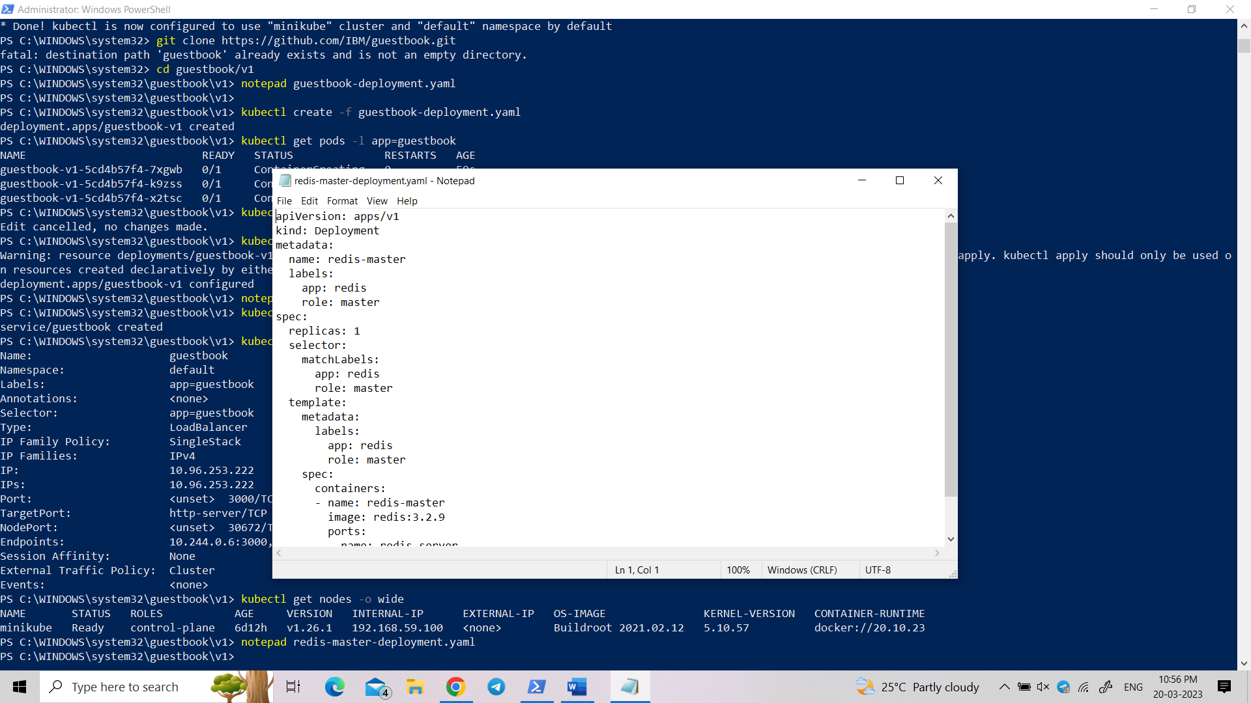

Create a redis Deployment, like we did for guestbook:

kubectl create -f redis-master-deployment.yaml:

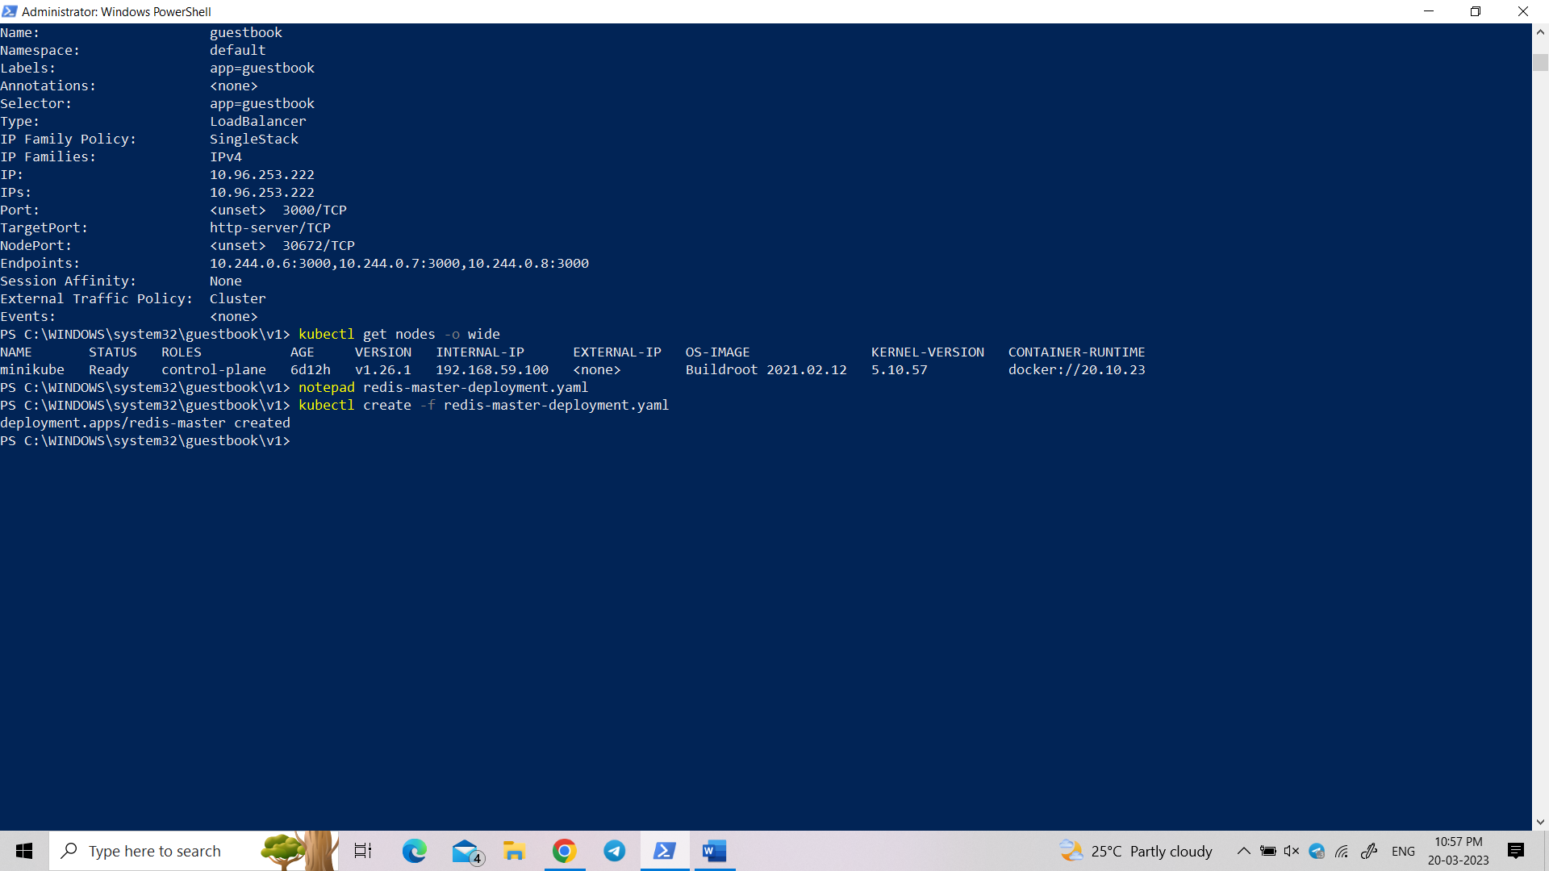

Check to see that redis server pod is running:

$ kubectl get pods -lapp=redis,role=master

NAME READY STATUS RESTARTS AGE

redis-master-q9zg7 1/1 Running 0 2d

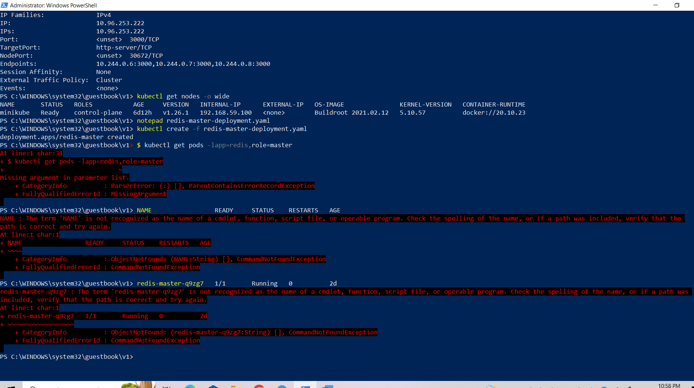

Create the service to access redis master:

kubectl create -f redis-master-service.yaml

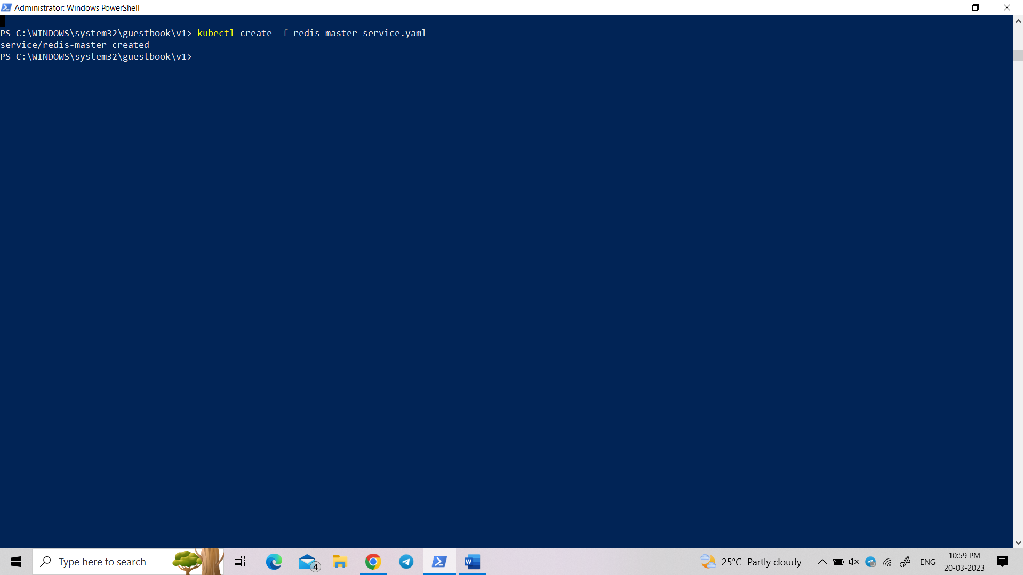

Restart guestbook so that it will find the redis service to use database:

kubectl delete deploy guestbook-v1

kubectl create -f guestbook-deployment.yaml

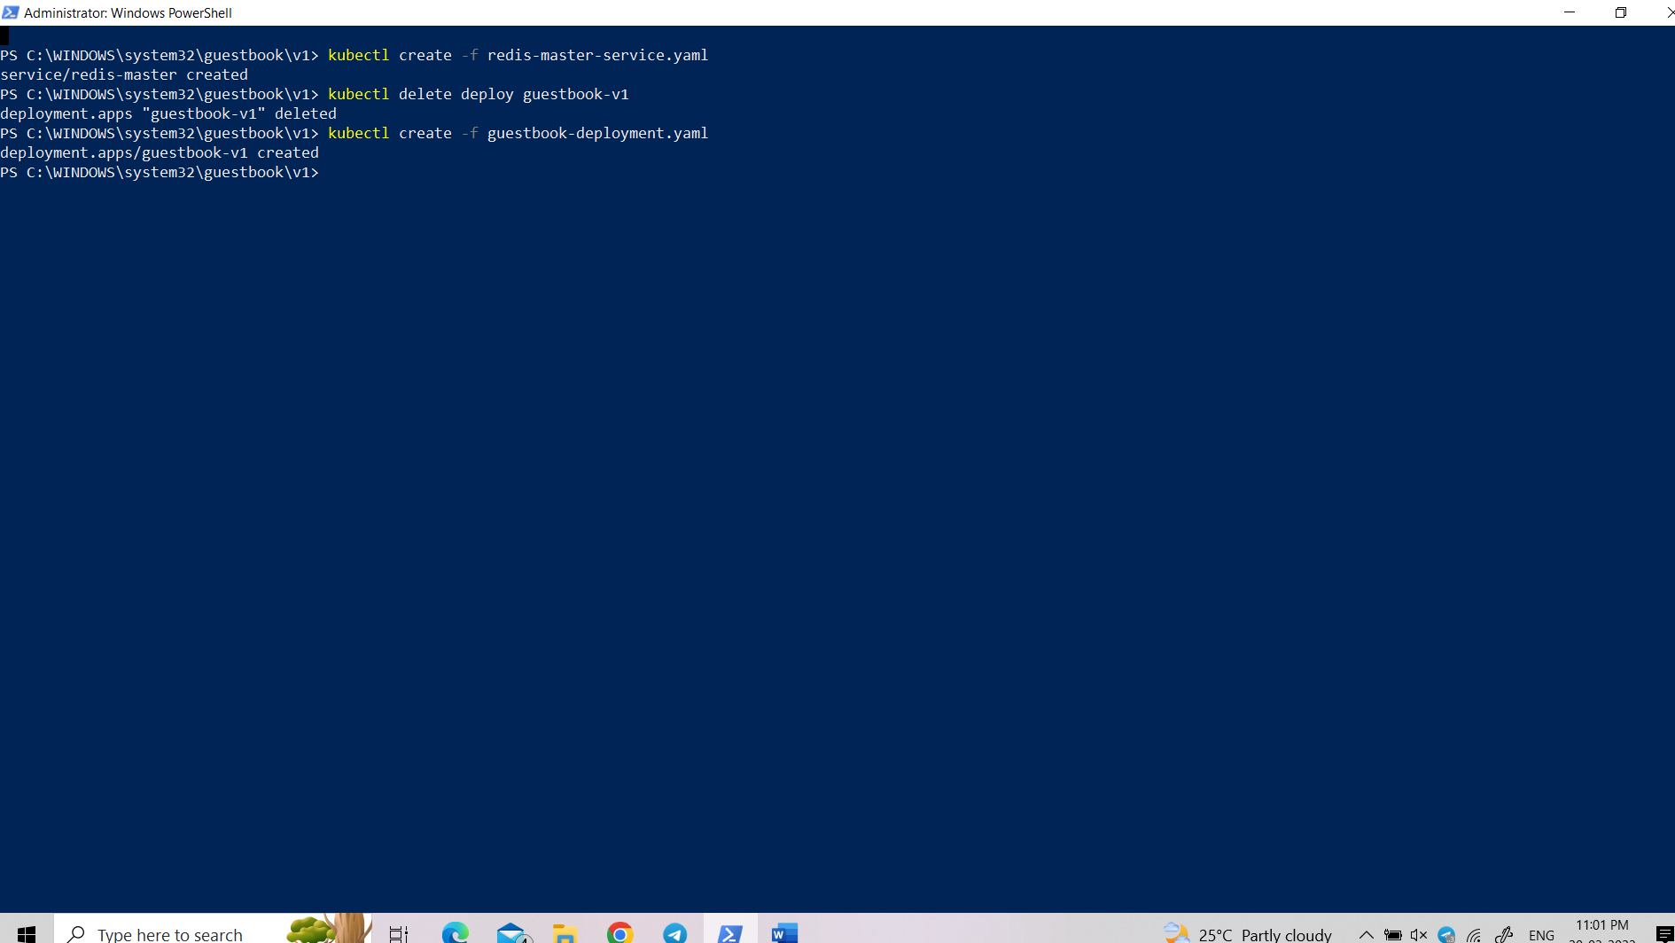

Open **redis-slave-deployment.yaml**

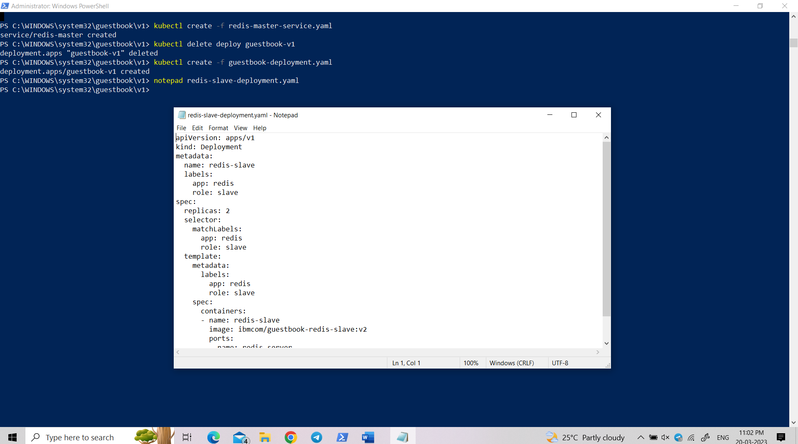

Create the pod running redis slave deployment.

kubectl create -f redis-slave-deployment.yaml

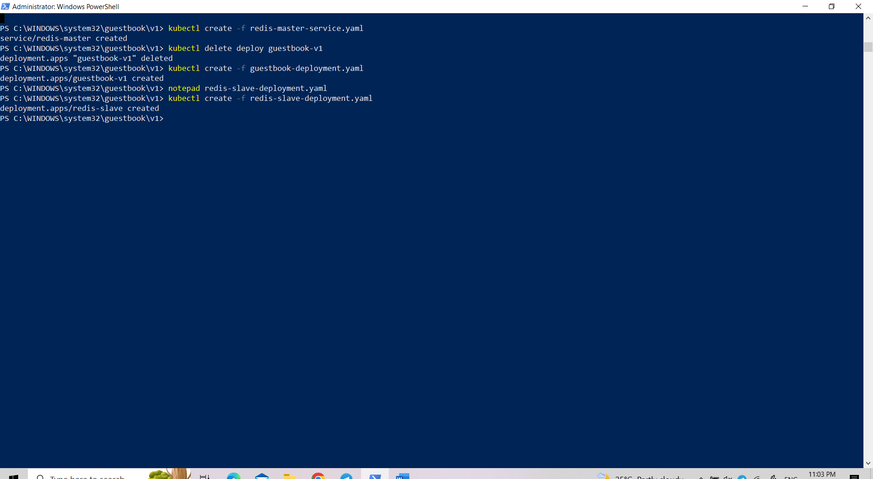

Check if all the slave replicas are running

$ kubectl get pods -lapp=redis,role=slave

NAME READY STATUS RESTARTS AGE

redis-slave-kd7vx 1/1 Running 0 2d

redis-slave-wwcxw 1/1 Running 0 2d

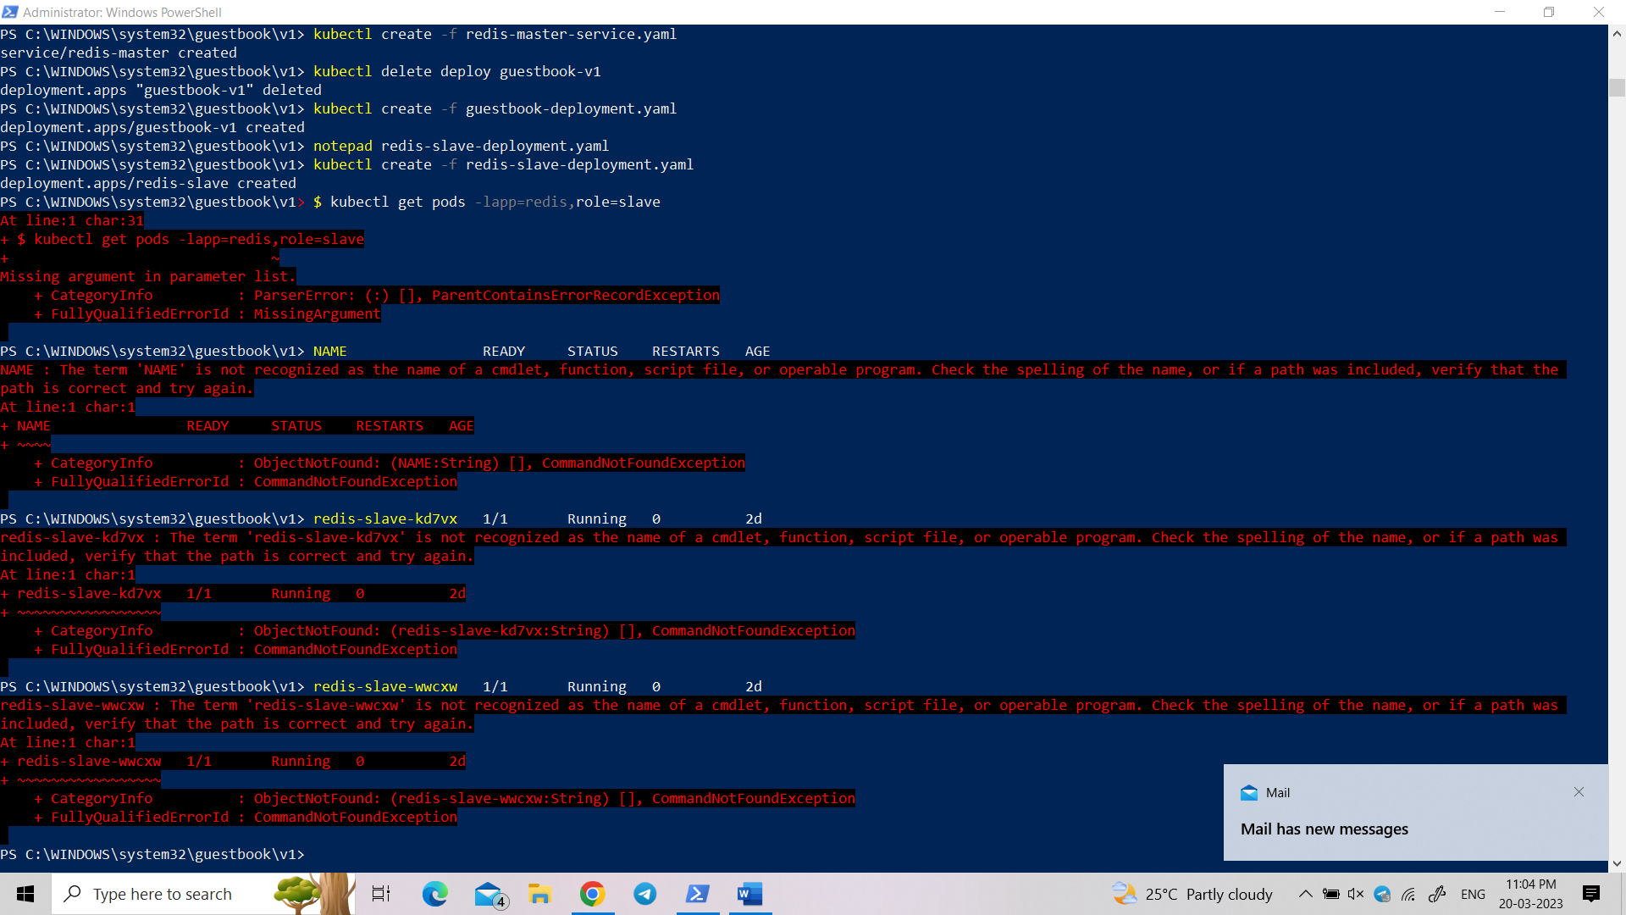

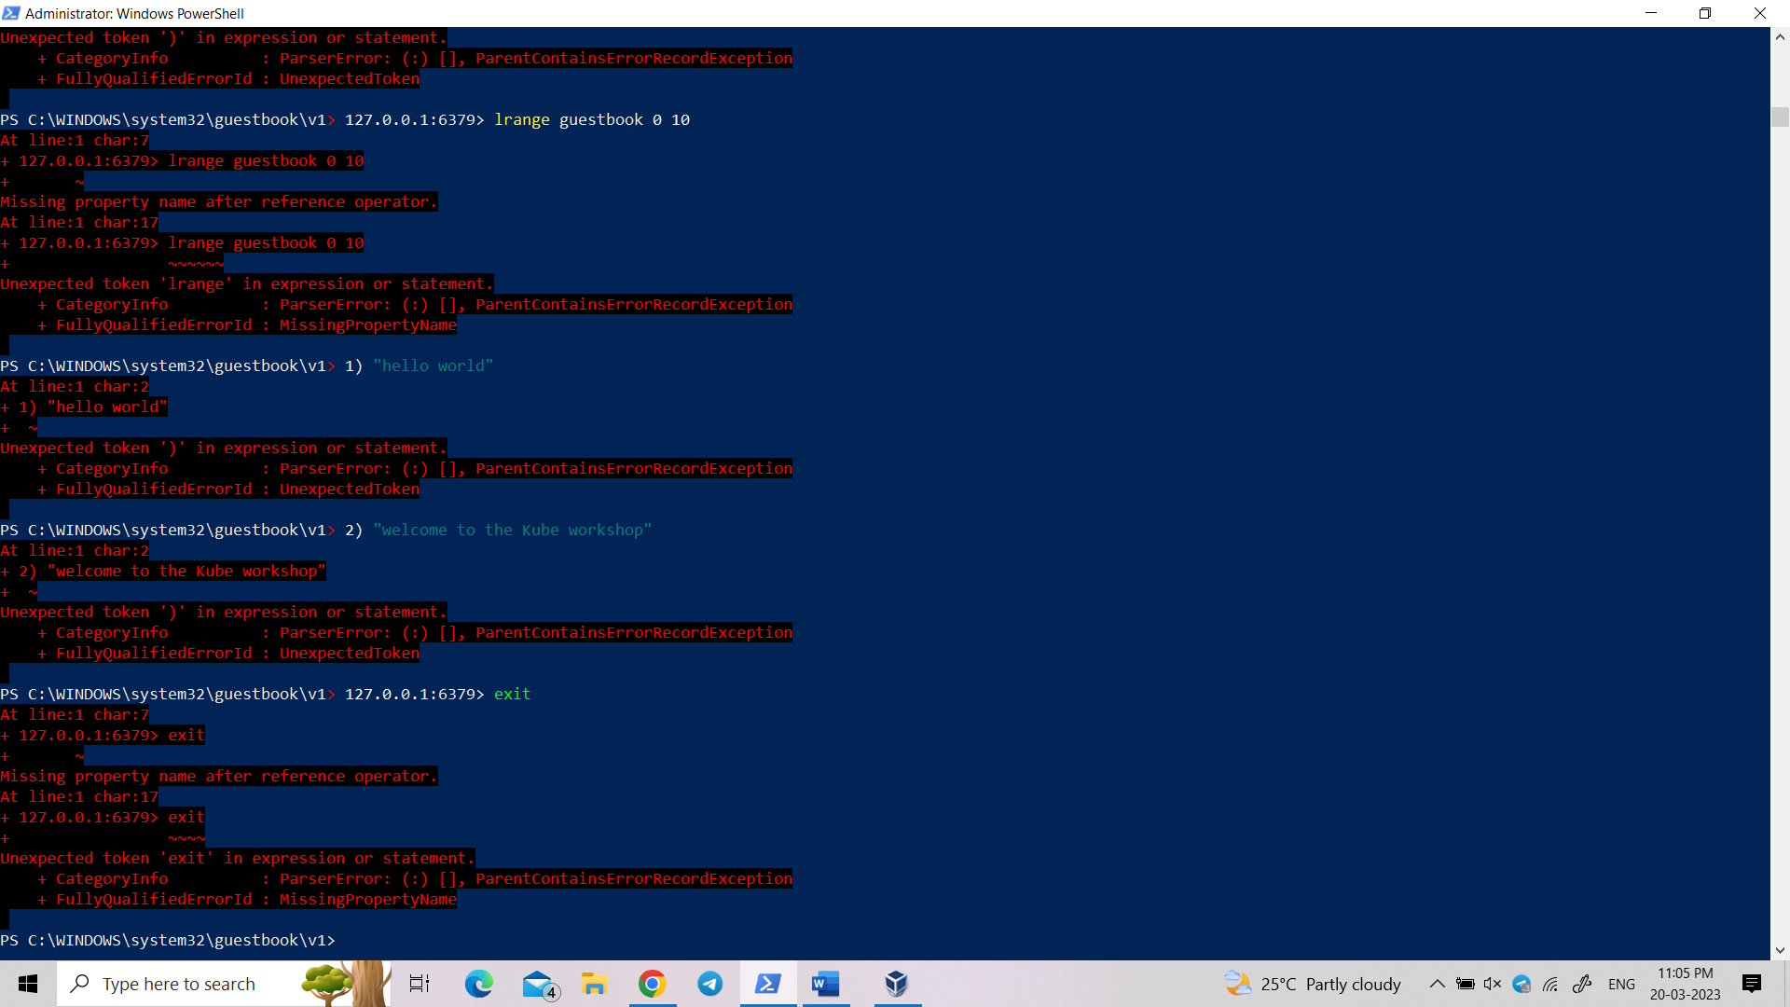

Open **redis-slave-service.yaml:**

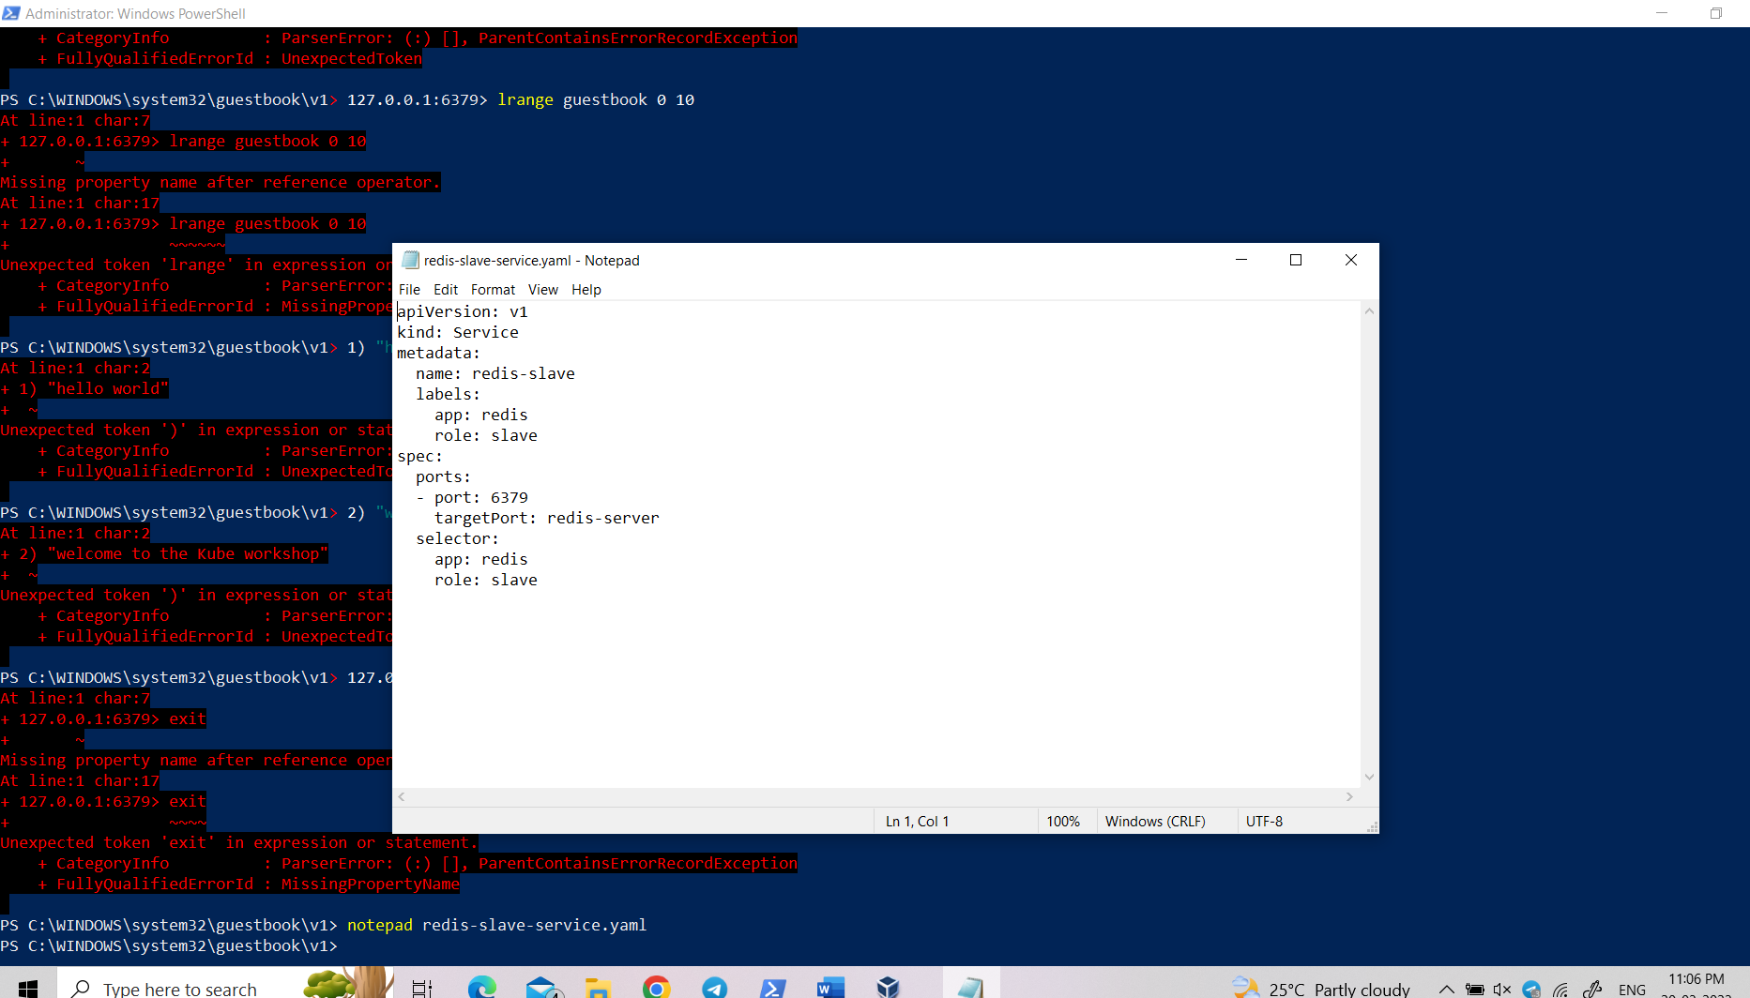

Create the service to access redis slaves.

kubectl create -f redis-slave-service.yaml

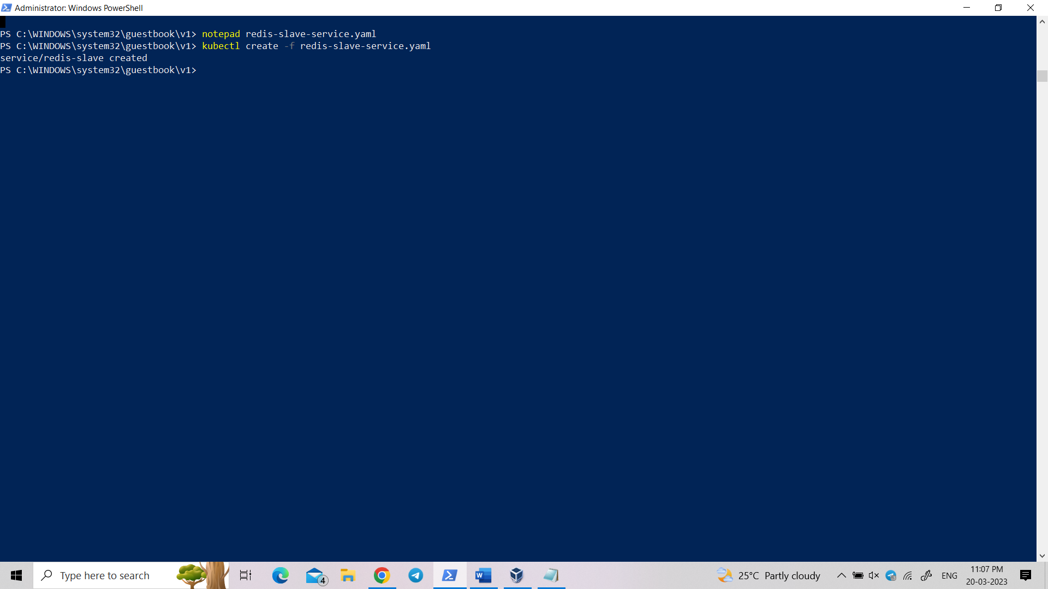

Restart guestbook so that it will find the slave service to read from.

kubectl delete deploy guestbook-v1

kubectl create -f guestbook-deployment.yaml

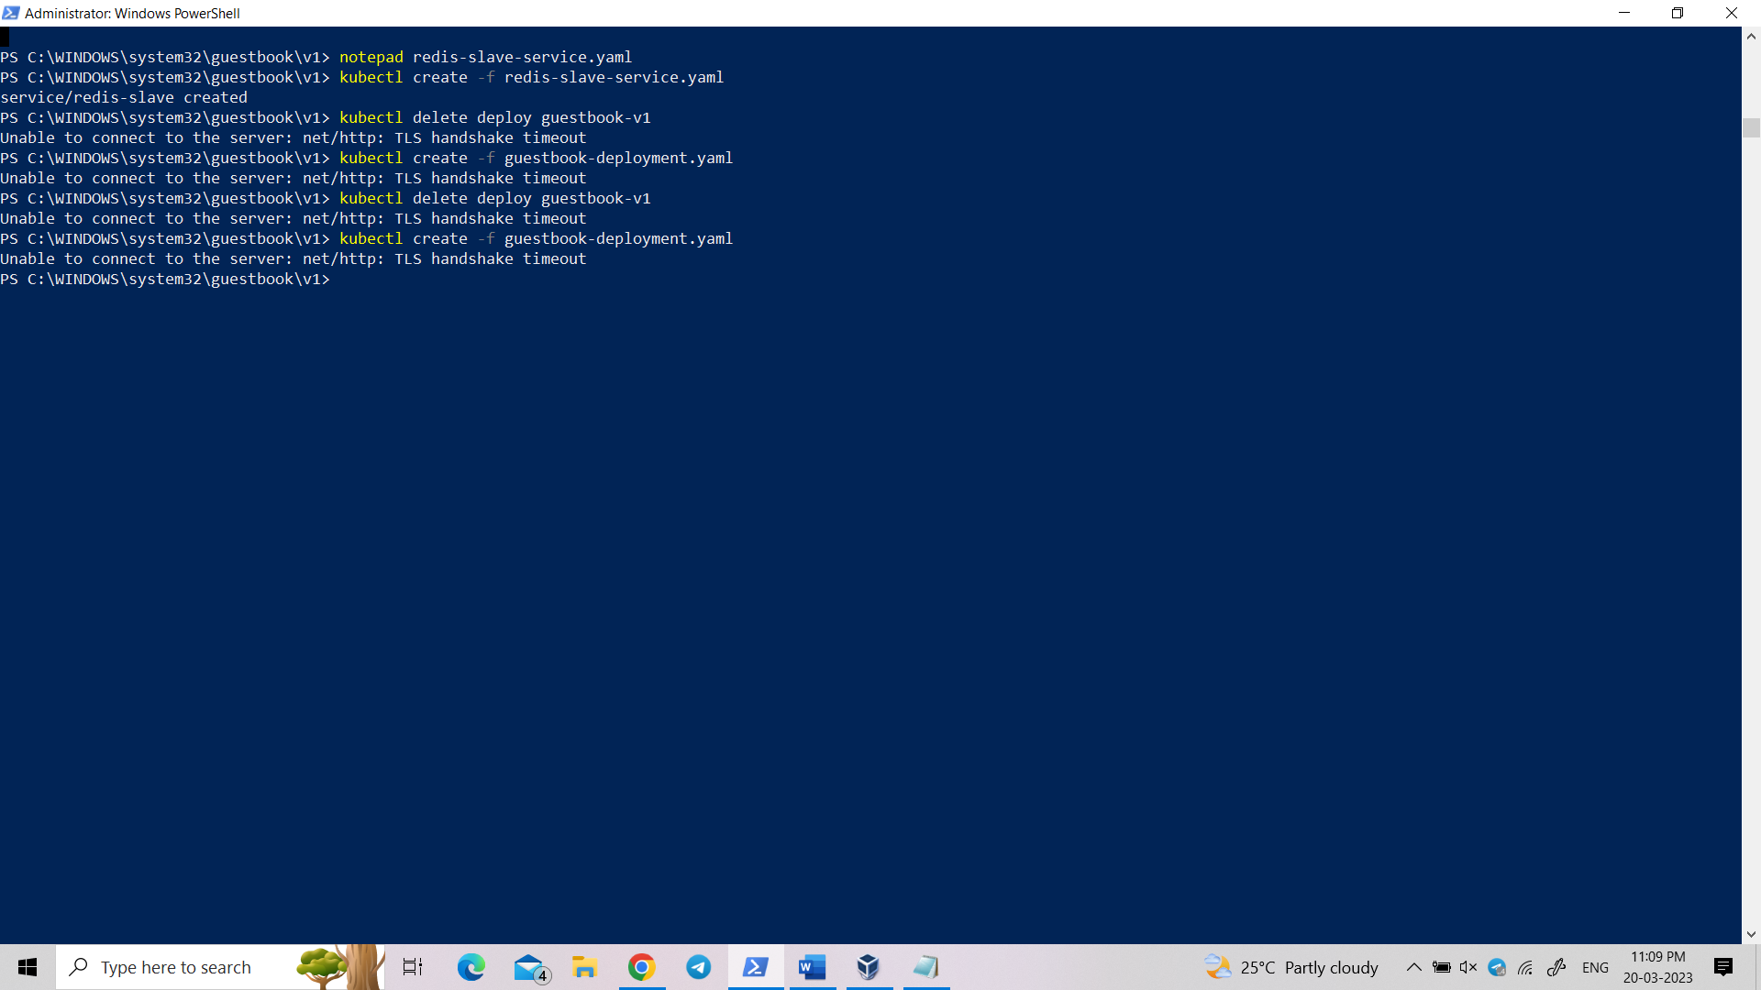

To end the lab type these commands:

kubectl delete -f guestbook-deployment.yaml

kubectl delete -f guestbook-service.yaml

kubectl delete -f redis-slave-service.yaml

kubectl delete -f redis-slave-deployment.yaml

kubectl delete -f redis-master-service.yaml

kubectl delete -f redis-master-deployment.yaml

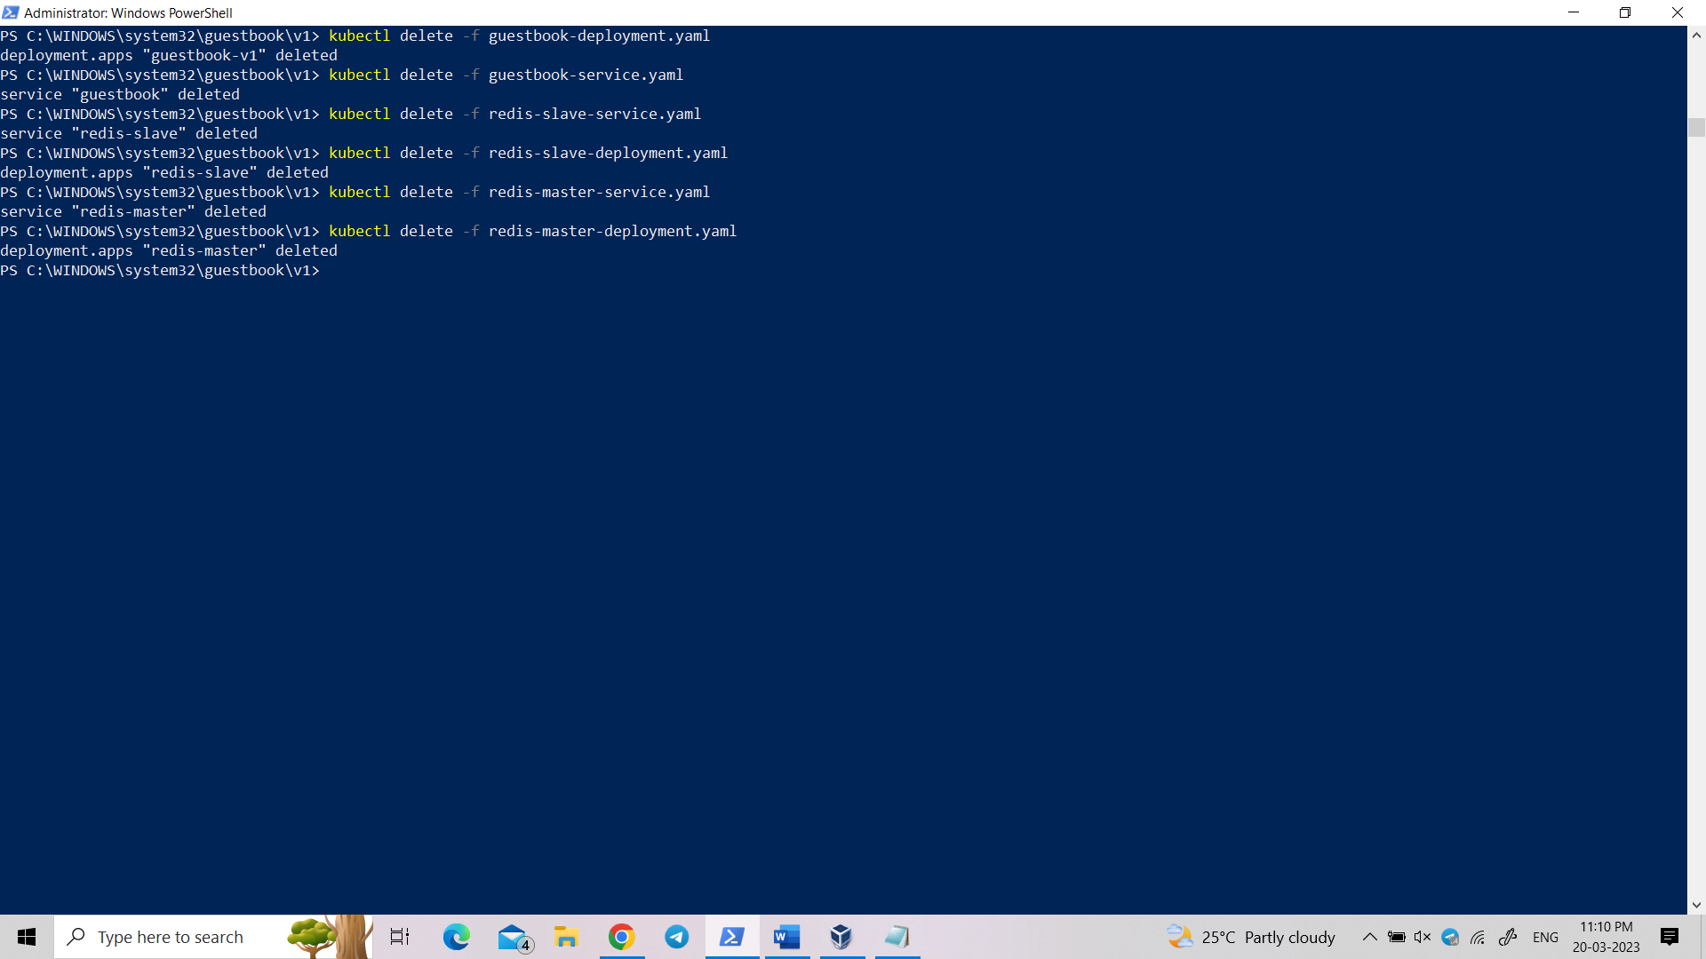

**Output:**

